Model Building Adding Dense Layers

|  |  |
| --- | --- |
| Date | 08 -11- 2022 |
| Team ID | PNT2022TMID13897 |
| Project Name | AI-Powered Nutrition Analyzer For Fitness Enthusiasts |

* A dense layer is a deeply connected neural network layer. It is the most common and frequently used layer.

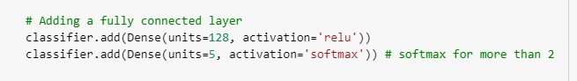

* The neurons in the last Dense layer, use Softmax activation to convert their outputs into respective probabilities.
* Keras provides a simple method, a summary to get the full information about the model and its layers.

